STUDENT PERFORMANCE PREDICTION SYSTEM
import pandas as pd
import numpy as np
from sklearn.model_selection import train_test_split
from sklearn.ensemble import RandomForestClassifier
from sklearn.metrics import accuracy_score, classification_report, confusion_matrix
import matplotlib.pyplot as plt
import seaborn as sns
# Load Dataset
df = pd.read_csv("C:/Student/Dataset/student_performance_data.csv")
print(df.columns)
Index(['student_id', 'gender', 'study_hours_per_day', 'attendance_percentage',
'assignment_score', 'midterm_score', 'final_exam_score',
'participation_score', 'internet_access', 'extra_classes',
'parent_education', 'sleep_hours', 'overall_score', 'grade'],
dtype='str')
# Create Pass/Fail Target
df["Result"] = df["final_exam_score"].apply(lambda x: 1 if x >= 50 else 0)
# Features
X = df[["study_hours_per_day","attendance_percentage", "sleep_hours","assignment_score","overall_score"]]
# Target
y = df["Result"]
# Train Test Split
X_train, X_test, y_train, y_test = train_test_split(X, y,test_size=0.2,random_state=42)
# Model
model = RandomForestClassifier(n_estimators=100, random_state=42)
# Training
model.fit(X_train, y_train)
# Prediction
y_pred = model.predict(X_test)
# Accuracy
print("Accuracy:", accuracy_score(y_test, y_pred))
Accuracy: 0.7965
print("\nClassification Report")
print(classification_report(y_test, y_pred))
Classification Report
precision recall f1-score support

0 0.70 0.55 0.62 598
1 0.82 0.90 0.86 1402

accuracy 0.80 2000
macro avg 0.76 0.73 0.74 2000
weighted avg 0.79 0.80 0.79 2000
print("\nConfusion Matrix")
print(confusion_matrix(y_test, y_pred))
Confusion Matrix
[[ 329 269]
[ 138 1264]]
# EDA & VISUALIZATION
# Study Hours vs Final Exam Score
plt.figure(figsize=(8,5))
sns.scatterplot(x=df["study_hours_per_day"],y=df["final_exam_score"])
plt.title("Study Hours vs Final Exam Score")
plt.show()
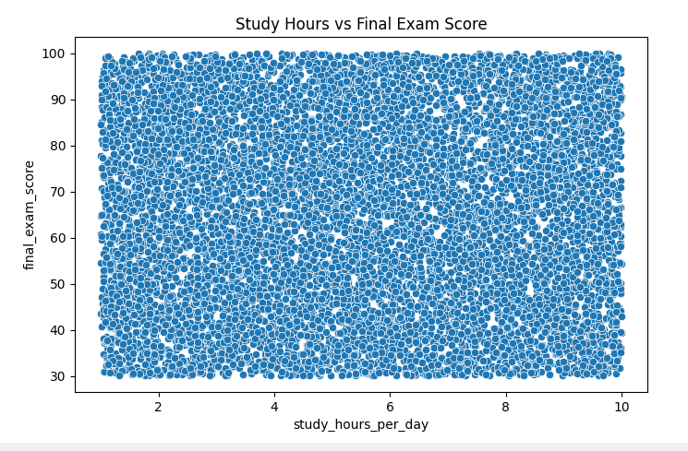
# Attendance vs Result
plt.figure(figsize=(6,4))
sns.boxplot(x=df["Result"],y=df["attendance_percentage"])
plt.title("Attendance vs Result")
plt.show()
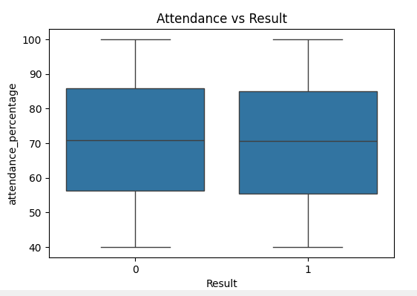
# Pass / Fail Count
plt.figure(figsize=(5,4))
sns.countplot(x=df["Result"])
plt.title("Pass / Fail Distribution")
plt.xticks([0,1],["Fail","Pass"])
plt.show()
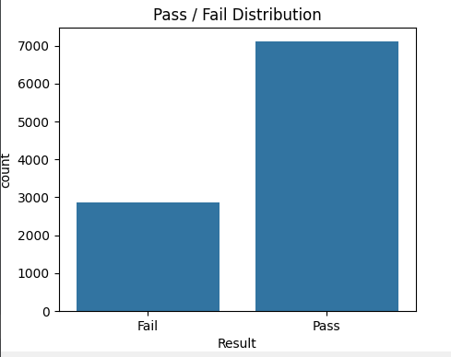
# Correlation Heatmap
plt.figure(figsize=(8,6))
sns.heatmap(df.select_dtypes(include=np.number).corr(),annot=True,cmap="coolwarm")
plt.title("Feature Correlation")
plt.show()
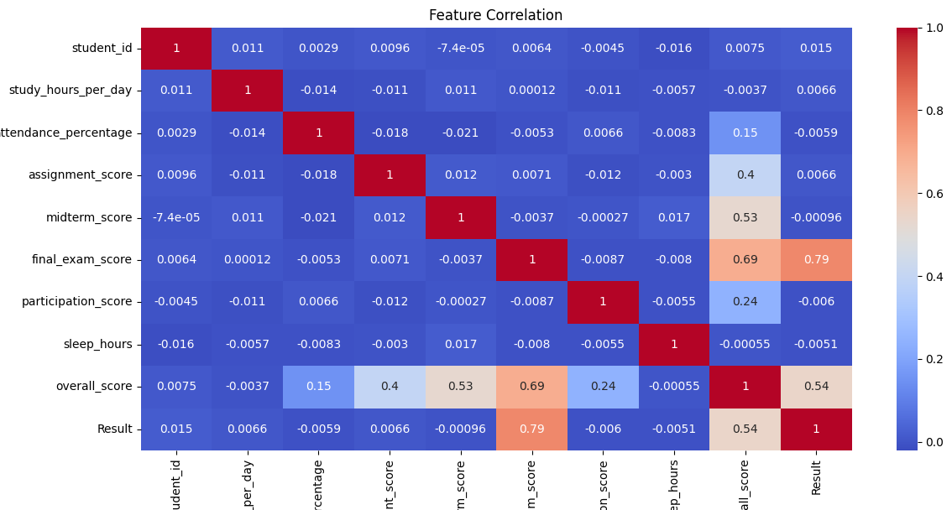
# FEATURE IMPORTANCE
importance = pd.DataFrame({"Feature": X.columns,"Importance": model.feature_importances_})
importance = importance.sort_values(by="Importance",ascending=False)
print("\nFeature Importance")
print(importance)
Feature Importance
Feature Importance
4 overall_score 0.467941
3 assignment_score 0.170890
1 attendance_percentage 0.128736
0 study_hours_per_day 0.117791
2 sleep_hours 0.114641

plt.figure(figsize=(8,5))
sns.barplot(x="Importance", y="Feature",data=importance)
plt.title("Feature Importance")
plt.show()
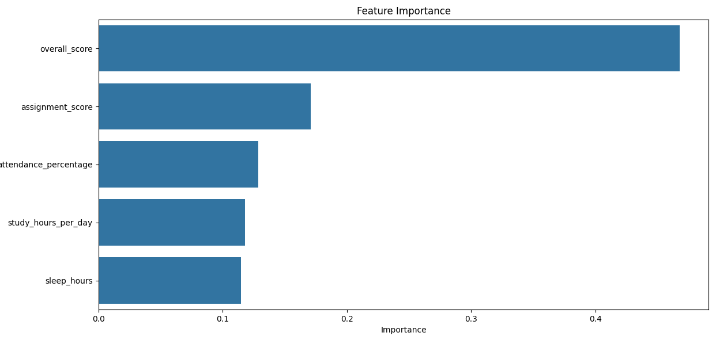

# NEW STUDENT PREDICTION
new_student = pd.DataFrame({"study_hours_per_day":[5],
"attendance_percentage":[85],
"sleep_hours":[7],
"assignment_score":[80],
"overall_score":[75]
})
prediction = model.predict(new_student)
if prediction[0] == 1:
print("\nPrediction : PASS")
else:
print("\nPrediction : FAIL")
Prediction : PASS

Flow Chart
Start
|
Load Dataset
|
Preprocess Data
|
Create Pass/Fail Target
|
Train-Test Split
|
Train Random Forest
|
Predict Result
|
Evaluate Accuracy
|
Generate Graphs
|
Display Result
|
End

STUDENT PERFORMANCE PREDICTION SYSTEM USING MACHINE LEARNING

1. INTRODUCTION

Student Performance Prediction System is a machine learning-based application developed to predict whether a student is likely to pass or fail based on academic and behavioral factors. The system analyzes student data such as study hours, attendance percentage, sleep hours, assignment scores, and overall scores. Educational institutions can use this system to identify weak students at an early stage and provide necessary support.

2. OBJECTIVE

The main objective of this project is:

• To predict student academic performance.
• To identify students who are at risk of failing.
• To assist teachers in monitoring student progress.
• To improve educational decision-making using machine learning techniques.

3. PROBLEM STATEMENT

Educational institutions often face difficulties in identifying students who may perform poorly in examinations. Manual analysis of student records is time-consuming and may not provide accurate insights. This project aims to automate the prediction process using machine learning algorithms.

4. DATASET DESCRIPTION

The dataset contains the following attributes:

• study_hours_per_day
• attendance_percentage
• sleep_hours
• assignment_score
• overall_score
• final_exam_score

Target Variable:

Result
Pass = 1
Fail = 0

Students scoring 50 or above in the final examination are classified as Pass, otherwise Fail.

5. SYSTEM MODULES

5.1 Data Input Module
Loads student data from CSV files.

5.2 Data Processing Module
Processes and prepares data for machine learning.

5.3 Model Training Module
Trains the Random Forest Classifier using training data.

5.4 Prediction Module
Predicts whether a student will pass or fail.

5.5 Visualization Module
Displays graphs and charts for data analysis.

6. METHODOLOGY

Step 1: Data Collection
Student records are collected from datasets.

Step 2: Data Preprocessing
The target variable "Result" is created from final examination scores.

Step 3: Feature Selection
Selected Features:
• Study Hours Per Day
• Attendance Percentage
• Sleep Hours
• Assignment Score
• Overall Score

Step 4: Train-Test Split
Training Data = 80%
Testing Data = 20%

Step 5: Model Training
Random Forest Classifier is trained using the training dataset.

Step 6: Prediction
The model predicts Pass or Fail for new student records.

Step 7: Evaluation
Performance is measured using:
• Accuracy
• Precision
• Recall
• F1-Score
• Confusion Matrix

7. MACHINE LEARNING ALGORITHM

Random Forest Classifier

Random Forest is an ensemble learning algorithm that builds multiple decision trees and combines their outputs to improve prediction accuracy. It reduces overfitting and provides better performance compared to a single decision tree.

Advantages:
• High accuracy
• Handles large datasets
• Reduces overfitting
• Supports feature importance analysis

8. DATA VISUALIZATION

The project includes:

• Study Hours vs Final Exam Score
• Attendance vs Result
• Pass/Fail Distribution
• Correlation Heatmap
• Feature Importance Graph

These visualizations help understand relationships among variables and identify important factors affecting student performance.

9. EXPECTED OUTPUT

The system predicts:

PASS
or
FAIL

Example:

Study Hours = 5
Attendance = 85%
Sleep Hours = 7
Assignment Score = 80
Overall Score = 75

Prediction: PASS

10. ADVANTAGES

• Early detection of weak students
• Improves teaching strategies
• Supports data-driven decisions
• Saves teacher effort and time
• Provides quick performance analysis.

11. LIMITATIONS

• Accuracy depends on dataset quality
• Missing data can affect predictions
• Emotional and psychological factors are not considered
• Performance may vary for different institutions

12. FUTURE ENHANCEMENTS

• Web-based application using Flask
• Mobile application integration
• Real-time student monitoring
• AI-based personalized recommendations
• Integration with Learning Management Systems (LMS)

13. CONCLUSION

The Student Performance Prediction System successfully predicts whether a student is likely to pass or fail using machine learning techniques. The Random Forest algorithm provides reliable predictions based on academic performance indicators. This system can help educational institutions improve student outcomes through early intervention and data-driven decision-making.

